Health & Mobility Guide

for Wheelchair Users

motivation
quality of life

website: www.motivation.org.uk

Motivation UK is a registered charity no. 1079358
and a company limited by guarantee
Registered in England & Wales no. 3916496

publication by Motivation

notes

transfer techniques

Clients name:

Your local service provider is:
(Please use your organisation stamp or fill out the details below)

Organisation name:

Address:

Telephone number:

Your therapist is:

Your technician is:

Your next appointment is:

Date with comments

etc.

date | time | with
wheelchair users 17

notes

Congratulations
on acquiring your wheelchair !

This booklet is a reference guide for the training you have received from your service provider. Your service team will go through this booklet with you and instruct you in wheelchair care and health management relevant to your personal needs.

It is very important that you take care of your health and your wheelchair.

This booklet covers:

1 How to handle your wheelchair
2. How to transfer in & out of your wheelchair
3. How to move while in the wheelchair
4. Pressure relief management and techniques
5. Other instructions given by your wheelchair service team

Remember to approach your service team if you require more information or instructions.

16
wheelchair users
wheelchair users 01

wheelchair handling
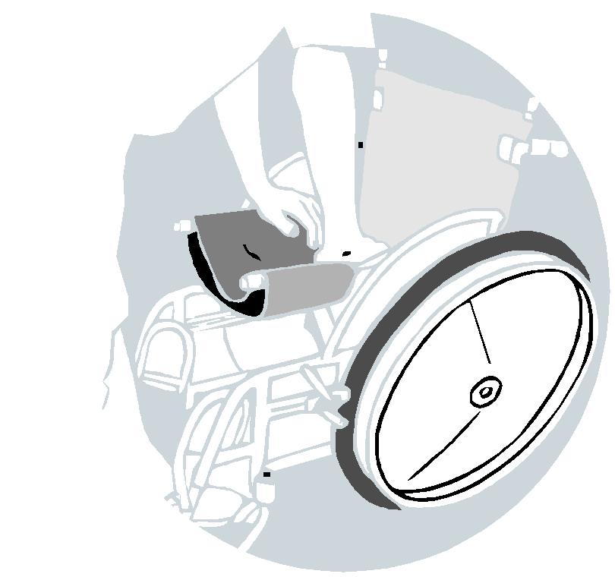

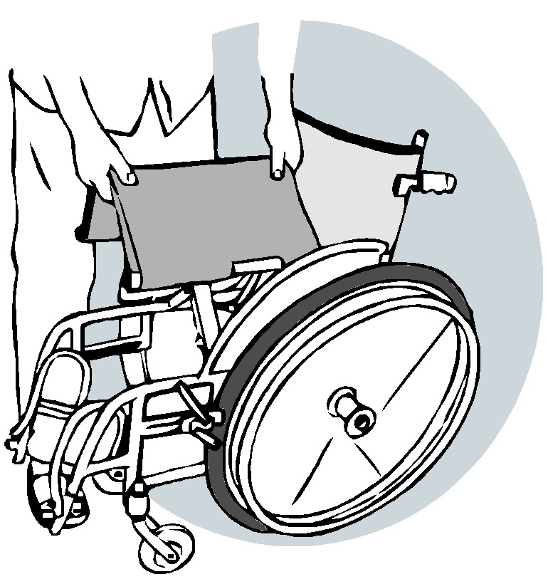

pressure relief techniques

Side to side leaning

For users with high level spinal cord injury
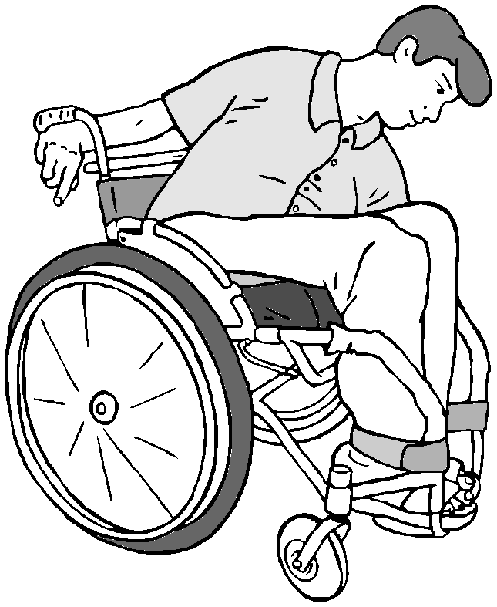

Hook right arm behind push handle for stability.

Lean to the left side for at least 15 seconds every half hour.

Repeat this for the right side.

folding the wheelchair
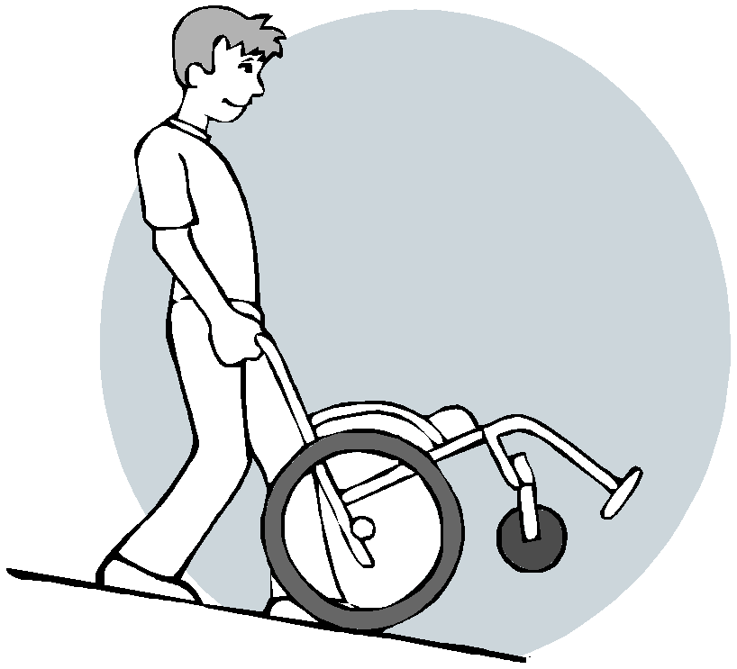

unfolding the wheelchair

Bending forward
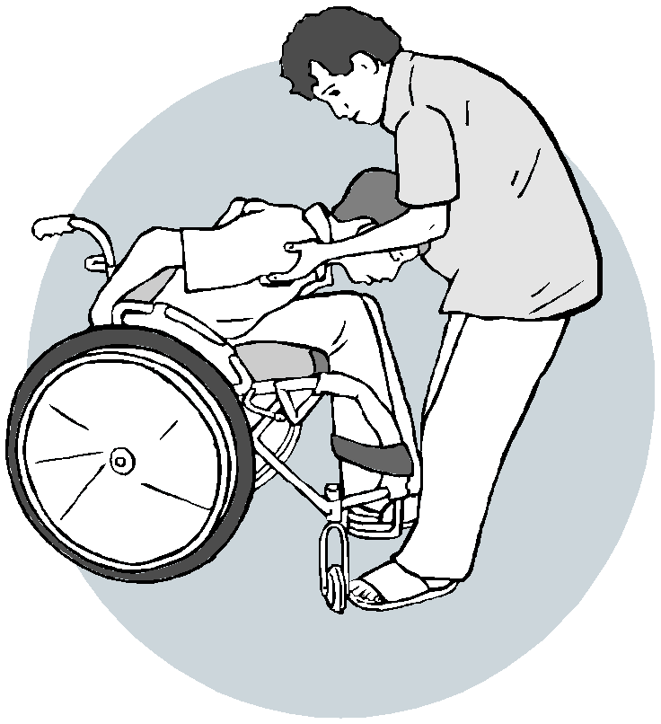

Lean forwards in the wheelchair to relieve pressure off the back and buttocks. An assistant should be in front of the user when doing this technique for safety.

A person with a high level spinal cord injury may need assistance to go down and get back up.

moving wheelchair down a ramp or slope

moving wheelchair up or down a step
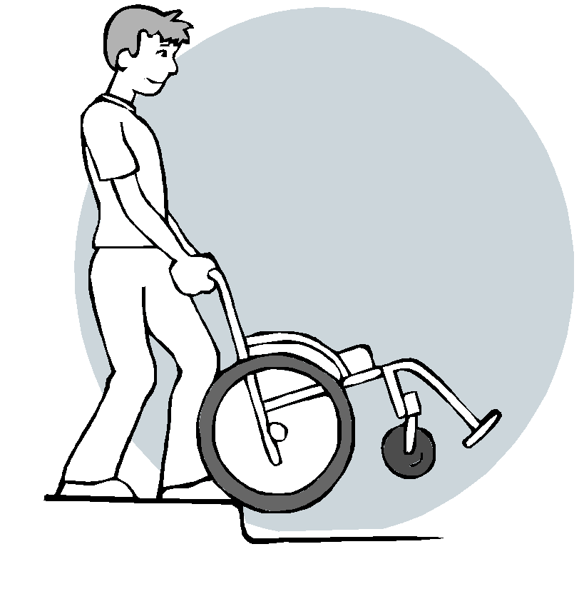

Be careful with wheelchair users who have blood pressure problems as they might get dizzy.

health & mobility guide for
02
wheelchair users
health & mobility guide for
wheelchair users
15

pressure relief techniques
wheelchair handling

Push up

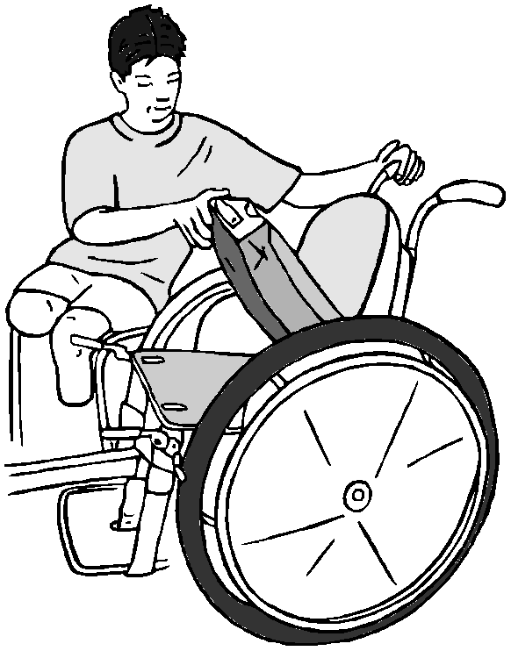

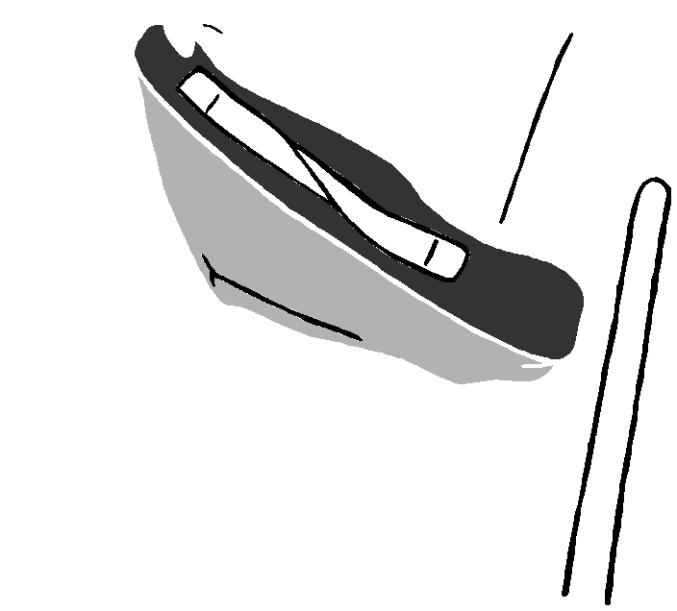

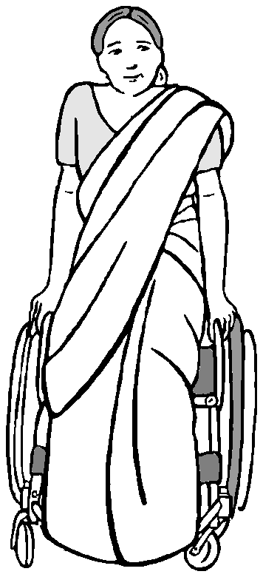

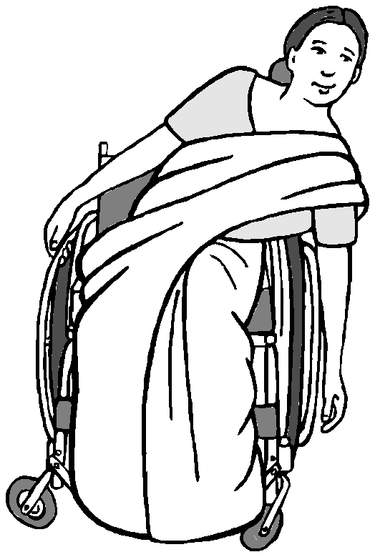

Push up on the armrest for at least 15 seconds every half hour.

You will need good upper body strength to practise this pressure relief.

Side to side leaning

For users with low level spinal cord injury
Lean to each side for at least 15 seconds every half hour.

Checking the cushion
14

Make sure the cushion is thick enough.

Make sure the cushion is as thick as when you received it.

When the cushion becomes thinner, you must get a replacement from your service provider.

Check if there are any objects for example, keys) on the cushion.

Putting the cushion on the seat
Make sure the cushion is placed correctly on the seat. The cushion ‘well’ should be at the back.

03

wheelchair handling

how to take care of the cushion cover & cushion
how to check and prevent pressure sores

Washing the cushion and cover
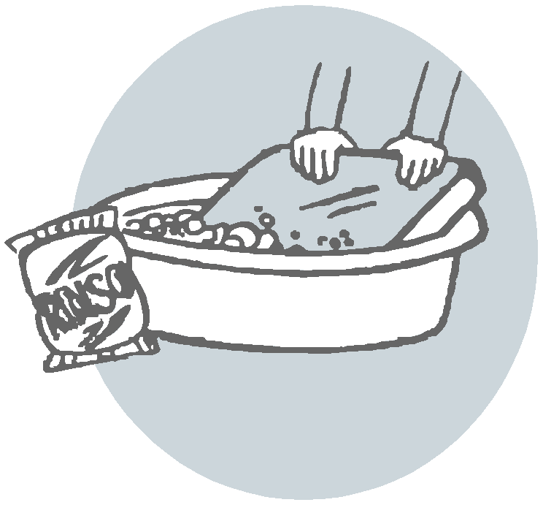

Wash the cushion and cover with

skin normal colour
check risk areas immediately after using a wheelchair

skin looks red or darker

if there is a blister or wound go to a doctor immediately

soap and water if it becomes dirty or wet with urine.

continue normal pressure relief routine

skin returns to normal colour after 10 minutes

increase pressure relief techniques

reduce time spent in wheelchair
skin does not return to normal colour after
10 minutes

keep pressure off area and stay out of wheelchair until colour returns to normal

identify the cause and try to correct

keep pressure off area and stay out of wheelchair until area or wound has healed

identify the cause and try to correct

monitor every day

Drying the cushion and cover

2 hours

Dry the cushion and cover under the sun if it gets wet.

DO NOT leave the cushion in the sun when it's dry.

Leaving the cushion in the sun for a long time will damage it and it will break more quickly.
Remember to take breaks from sitting.

for example lie on your stomach during the day

health & mobility guide for
04
wheelchair users
health & mobility guide for
wheelchair users

13

pressure relief management
independent transfer techniques

Remember

Any part of the user that comes into contact with the wheelchair can be an area where a pressure sore develops.

All wheelchair users are at risk of a pressure sore.
It is easier to prevent pressure sores than to treat them. Pressure sores can usually be prevented by
Pressure relief techniques
Use of a pressure relief cushion
Good posture
Regularly changing position
Checking the skin regularly

Independent standing
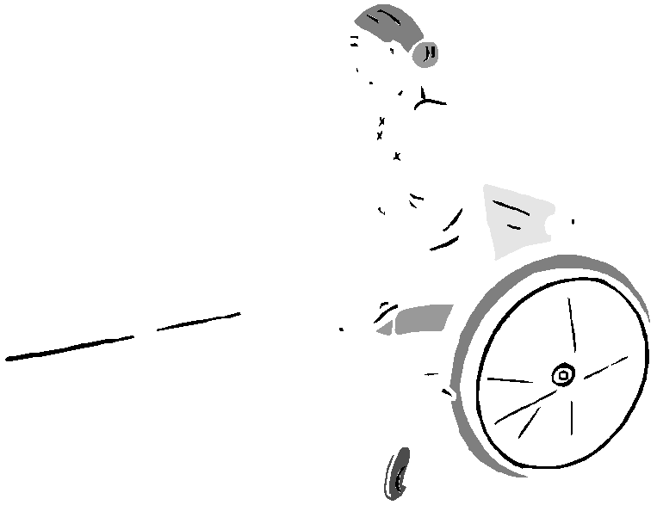

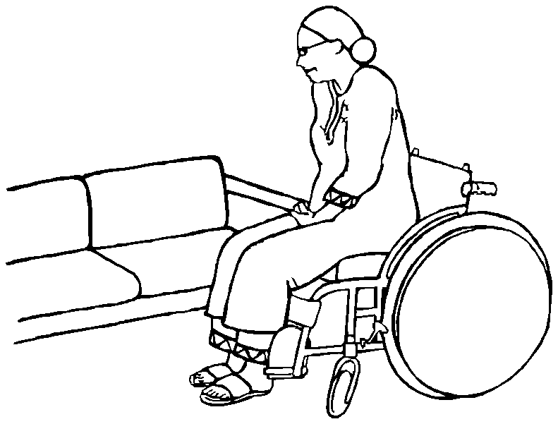

Position wheelchair close and at an angle

Brakes on
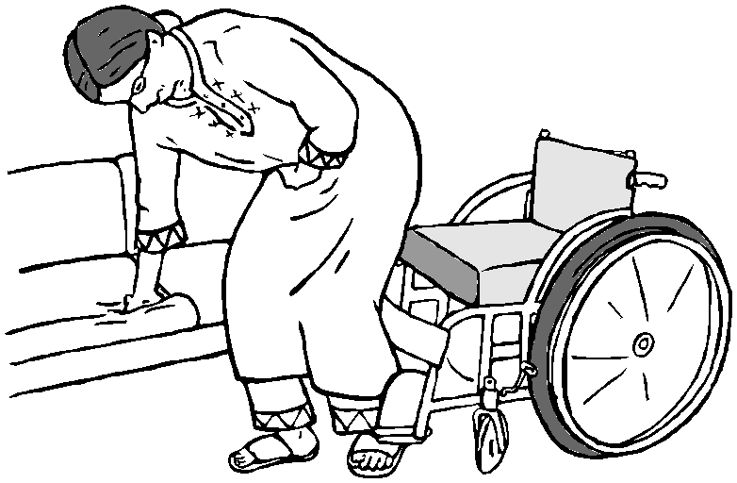

Footrests up

How to check for pressure sores
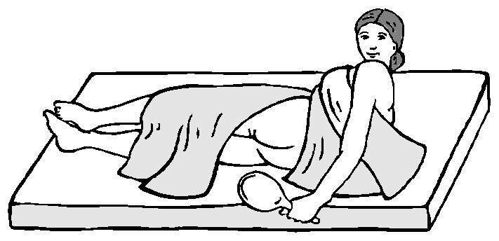

Check daily as part of a regular routine.
- Before getting out of bed in the morning
- Before going to sleep at night

A mirror can be used to check parts of the body that cannot be seen.

An assistant should check if a wheelchair user is unable to do this themselves.
Move forward in wheelchair

Position feet clear of footrest

Use arms for assistance
and transfer from the wheelchair to the chair
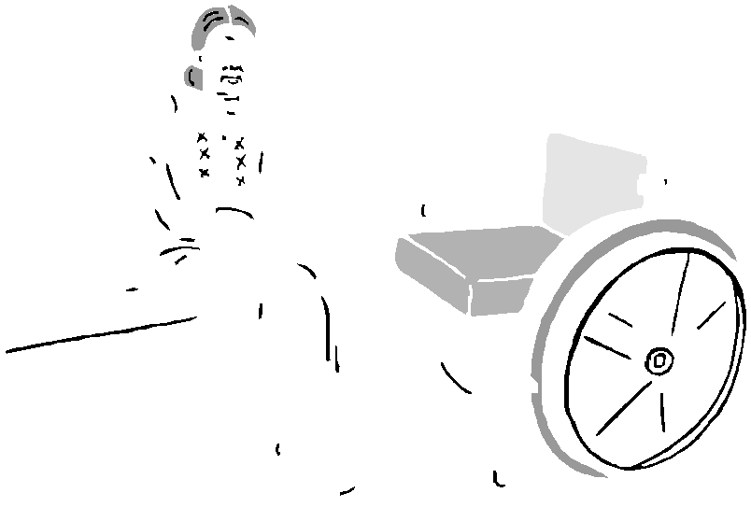

health & mobility guide for
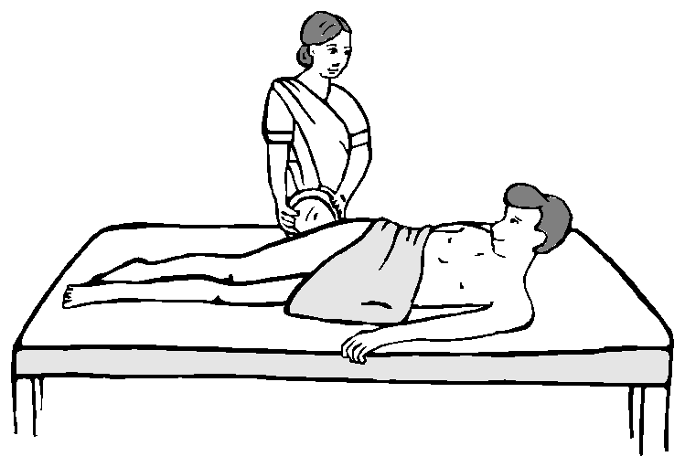

12
wheelchair users
health & mobility guide for
wheelchair users
05

independent transfer techniques

Independent non-standing legs up
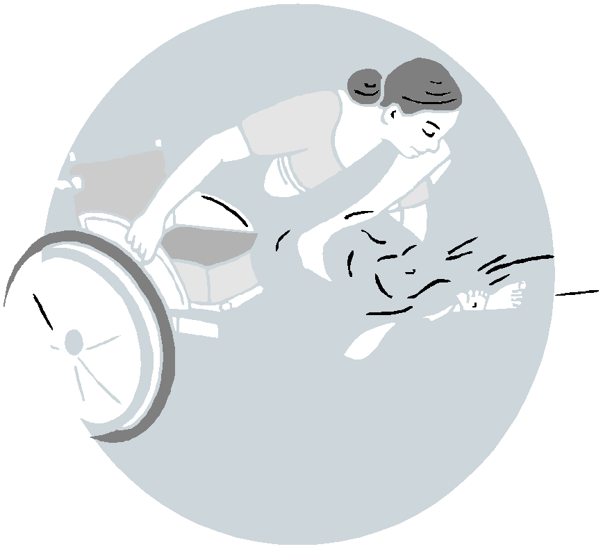

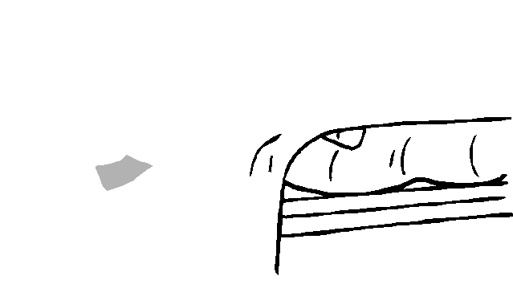

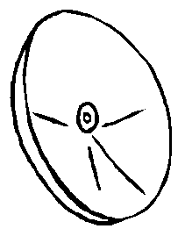

Position wheelchair close and at an angle
Brakes on
Move forward in wheelchair Position feet clear of footrest Lift the feet onto the bed
Use arms to transfer
wheelchair mobility

Propelling down slopes
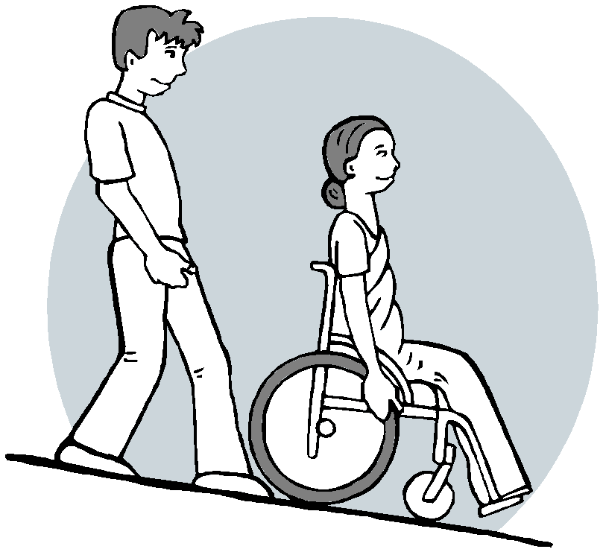

Lean backwards and let the push rim slowly slide through fingers.

Arms should be forwards and straight with equal pressure on both hands.

Be careful at the bottom of a slope. Footrest might catch on the level ground and might tip the wheelchair forwards.

Independent non-standing legs down
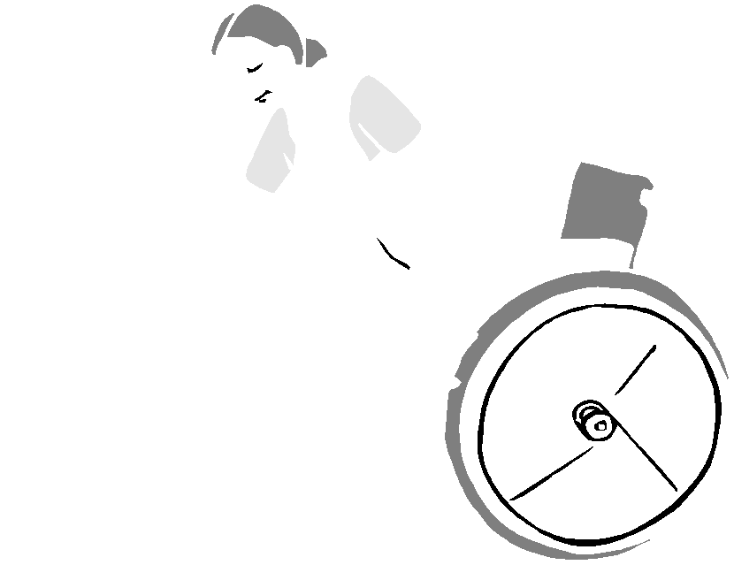

To go up and down a flight of stairs

Position wheelchair close and at an angle
Move forward in wheelchair
Brakes on
Position feet clear of footrest
Use arms to transfer
Position the wheelchair with the rear wheels against the bottom
step. The rear helper tips the wheelchair into a tilted back position.

The second helper holds the front of the wheelchair frame – NOT the footrests or the user themselves.

On the count of 3 the helper pulls up and back on the next step and the lower helper pushes up and back.

Repeat for each step slowly steadying the wheelchair on each step.
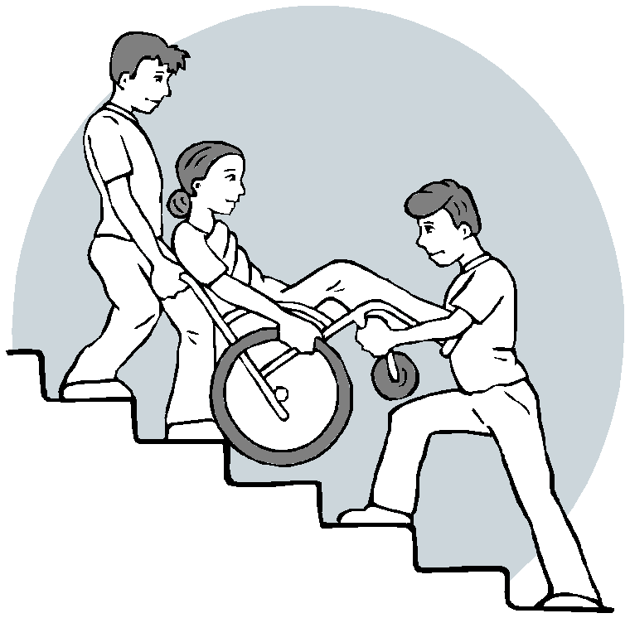

health & mobility guide for
06
wheelchair users
health & mobility guide for
wheelchair users
11

wheelchair mobility
assisted transfer techniques

Pushing user over rough ground

Assisted standing

The assistant tilts the wheelchair on it’s back wheels.

The assistant needs to tip the wheelchair back to a point where it is balanced but will not tip over.

The assistant needs to have good control on both push handles.

User pushes the wheelchair from the front of the wheels to assist.
Position wheelchair close and at an angle
Brakes on
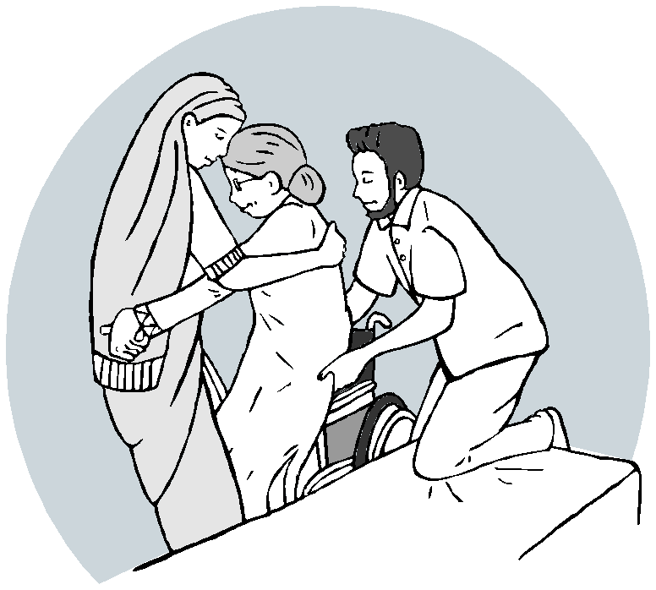

Footrests up
Move user forward in wheelchair Position feet clear of footrest Helper uses knees to block the user’s legs
Helper’s arms outside user’s arms and squeeze
Lean user forward
User holds around helper’s waist Main helper counts '1,2, 3 lift' Second helper assists lift

Propelling up slopes
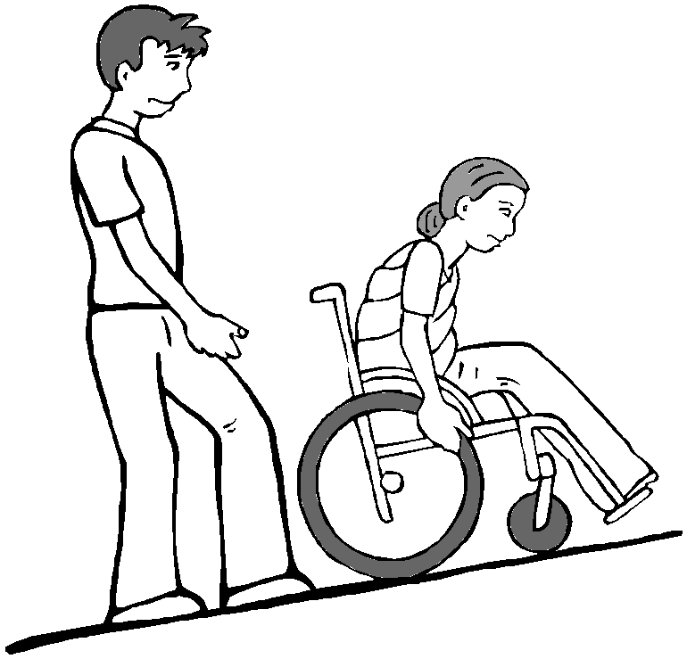

Assisted non-standing

For steeper slopes, an assistant should stand behind the wheelchair.

Hands should be ready on the push handle to hold the wheelchair if it tips backwards.
Position wheelchair close and at an angle
Main helper has one foot on the floor and one knee on bed
Fold user's arms
Main helper puts their arms through user’s arms
Main helper holds user’s forearms and squeezes against chest
Main helper counts '1, 2, 3 lift' Second helper lifts user’s legs
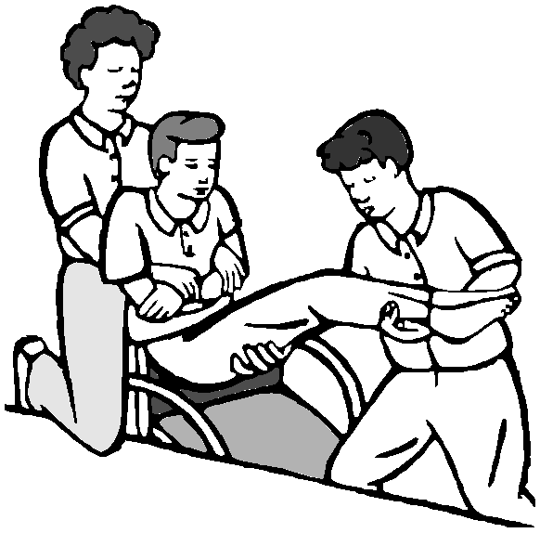

health & mobility guide for
10
wheelchair users
health & mobility guide for
wheelchair users
07

wheelchair mobility
wheelchair mobility

Hand position for pushing Stopping the wheelchair

Push rim between pad of thumb and curled fingers
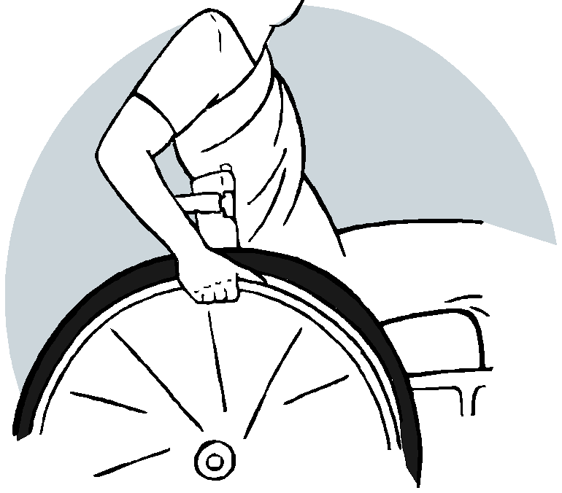

Lean backwards with arms straight

Squeeze the front of the push rims to slow down

Do not suddenly grip tight as the wheelchair may tip forwards
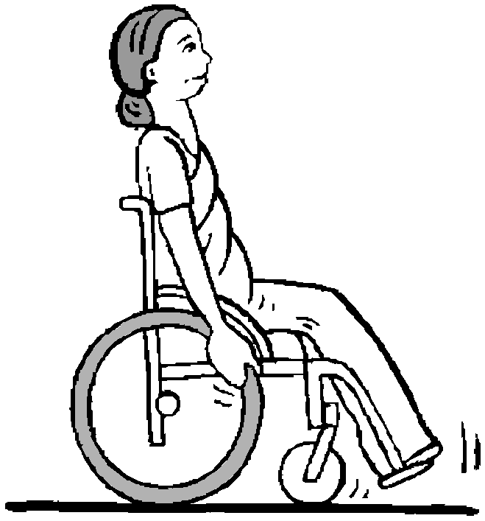

Propelling forward

Before starting to push, get in a pushing position

Pushing position: Bend your head or head and body forwards slightly
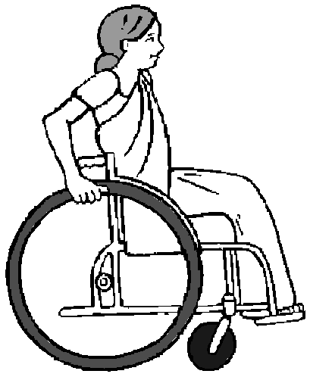

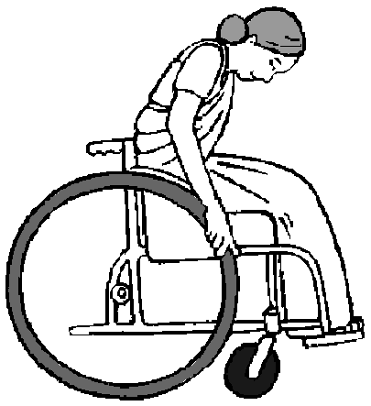

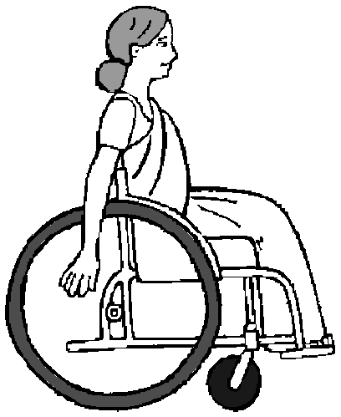

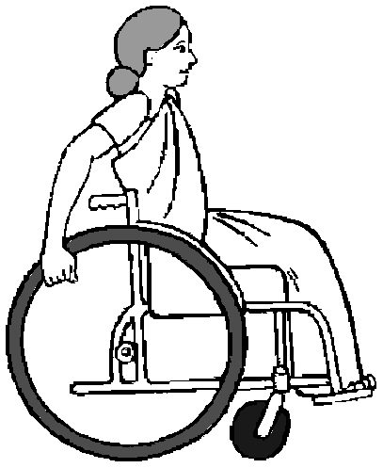

Turning the wheelchair

To turn push forwards with one hand
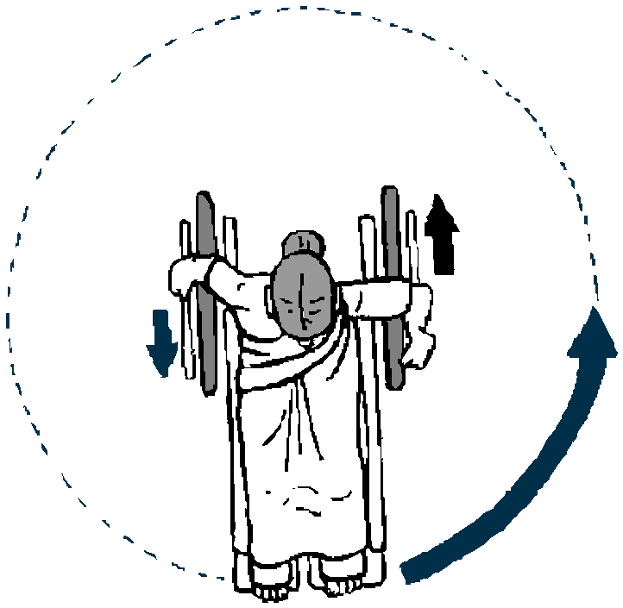

At the same time the other hand propels backwards

Push with the hands on the top of the push rims
Push with arms outstretched to the front of the wheelchair
Let arms swing back before starting the push again

health & mobility guide for
08
wheelchair users
health & mobility guide for
wheelchair users
09

